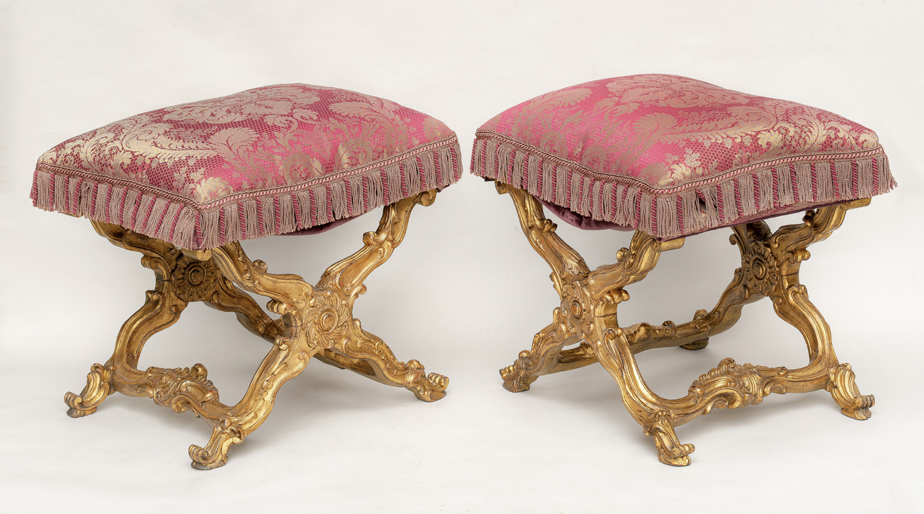
A pair of Italian giltwood carved folding stools, with a rectangular loose cushion seat, above an ‘X'-frame baluster supports, carved with scrolls, centred by a patera, joined by shaped stretchers centred by a stylised scallop-shell, on outward scrolled feet.
Turin, Circa 1740
Height: 19 ¾ in. (50 cm)
Width: 22 ½ in. (57cm)

Provenance:
Rodolphe Kann (1844–1905);
Acquired by Duveen Brothers in 1907 (along with the entire Kann collection);
Possibly acquired from Duveen Brothers by Archer Huntington (1870–1955) and then donated to Yale University.

Comparative Bibliography:
G. Wilson and C. Hess, European Decorative Arts in the J. Paul Getty Museum, Los Angeles, J. Paul Getty Museum, 2001, p.212, no.425, illus. (coming from the Palais de Fontainebleau).
R. Antonetto, Minusieri ed ebanisti del Piemonte, Daniela Piazza editore, 1985, p.223.
G. Wilson, Decorative Arts in the J. Paul Getty Museum, J. Paul Getty Museum, 1977, p.33, no.42, illus.
G. de Bellaigue, The James A. de Rothschild Collection at Waddesdon Manor. Furniture, Clocks and Gilt Bronzes, vol. II, Fribourg, 1974, pp. 641–42, n. 143.
A. Gonzàles Palacios, Casa D’oro, gli stili dei mobili, Fratelli Febbri editori, Milano 1966, vol. I, p. 112.
V. Viale, Mostra del Barocco Piemontese, Turin 1963, tabs. 185–186a.

Comparative Examples:
Our pliants are closely modelled after the iconic ones designed by Filippo Juvarra (1678–1736) for the Gabinetto Cinese in the Turin Royal Palace (fig.1). The present examples were more probably designed by Benedetto Alfieri (1699–1767), the successor to the Sicilian Juvarra as royal architect. Alfieri designed them for another interior of the Turin Royal Palace, the Gabinetto delle Miniature, where some stools from the same set can still be found (fig.2).
A set of four stools of this model was sold to Founes from the collection of Jacques Doucet, Galerie Georges Petit, Paris, June 7, 1912, lot 276 (28,500 Francs). Three further models are in the James A. de Rothschild Collection, Waddesdon Manor, see Geoffrey de Bellaigue, The James A. de Rothschild Collection at Waddesdon Manor: Furniture, Clocks and Gilt Bronzes, vol. II, London, 1974, p. 641.
Another group of stools, dating from c.1735, arrived in the Palais de Fontainebleau before entering the collections of the J. Paul Getty Museum in Los Angeles (through the mediation of the New York firm of Matthew Schutz). (Fig.3).

The pliants was considered a seat of favour but also of subjugation. It marked the privileged social rank of those who were allowed to sit in front of the king or a prince of the blood. More often, however, they remained unused, being displayed in the official apartments to accentuate the standing position of those who had neither the right nor the honour to sit before the majesty of a powerful person.

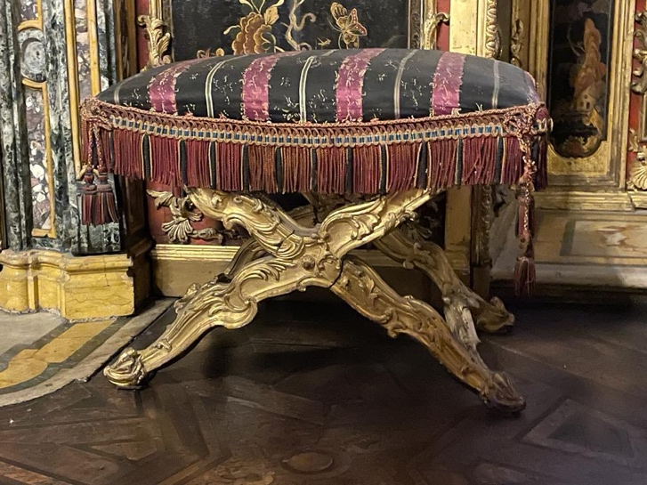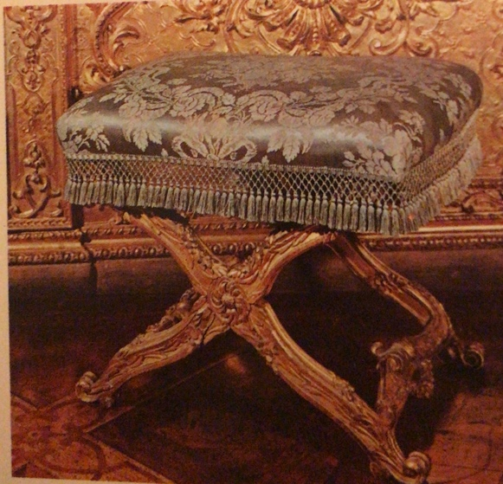
1.Torino, Palazzo Reale, Gabinetto Cinese 2.Torino, Palazzo Reale, Gabinetto delle Miniature

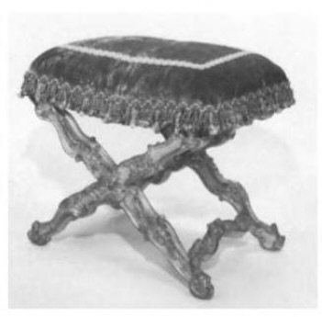
3. J.P.Getty Museum inv.n. 74.da.26

